Visual Basic 2005 Express Edition basics
You want to know the basics of programming because you just started or maybe you just haven’t grasped the concept yet? Here we go! A tutorial for you.
This Tutorial Includes
1.Making a project, naming objects, and changing visualizations.
2. How to think that, if this check box is checked, then I want this to happen. If it isn’t, I want this to happen.
3. Saving a project and getting the “.exe”
4.Using an Open File Dialog to open a map, and resigning it.
5.Using picture boxes to hold a picture of your choice.
6.Making a basic web browser.
1. Making a project, naming objects and styling.
Ok, so. Run your Visual Basic 2005 Express Edition. At the top left. Click File->New Project
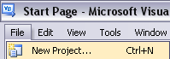
Now. This will pop up:
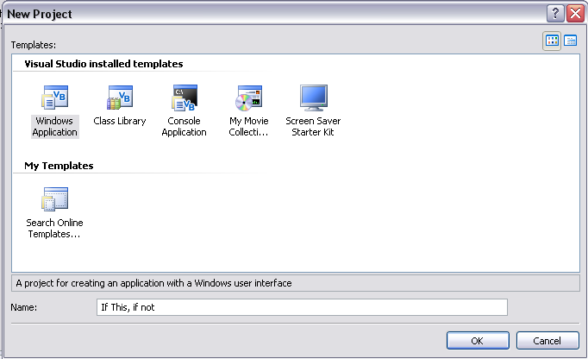
Well… we will be making a windows application. So click Windows Application once. Then in the name below, name your project. Then click “OK.” Wait for windows to create the project, then you will be left at this…
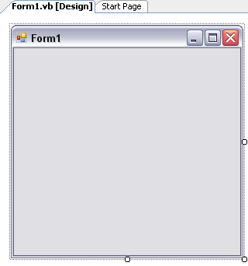
This is your Windows Form. This is the design of your project. You can resize it by clicking the little circles around it and dragging that, to make the size you want.
Now, we want to make the top of the from (see where it says Form1?) Say My Application. So… At the bottom left should be a properties container. Click on the form with one click (so its selected) and in the properties find “Text”
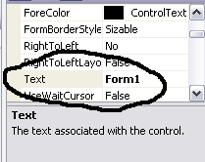
Click the text to the right (in our case, Form1), and change it. I will change it to My Application. See? This changes the text at the top, see?
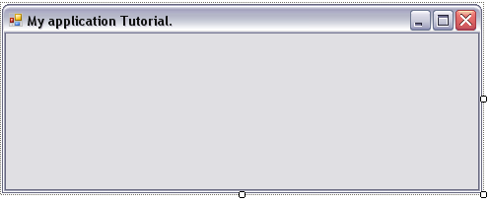
Now. Say we want to make it non sizeable(so the users of the application cannot resize it. In the properties area, find “FormBorderStyle” and change it to FixedToolWindow.
Here is your outcome.
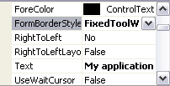
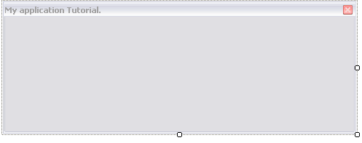
Nice job! Now... Lets change the colour of the Form, cause maybe you don’t like the original grey.
So… In the properties window, find Back Colour. (Notice Below it is Backround Image in which you can add your own image)
So… click on the drop down.
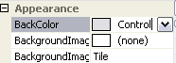
And find the colour of your choice! There you go, you successfully changed the colour.
Now we will be adding a objects to the form(buttons).
So near the top. Is a button like this…
See? The hammer?
Click on it and on the left will be many different objects you can add to your form.
I will be adding a button in this tutorial. So double click button.
This will show up in your windows form.
You can move it around. And see how the name is “Button1”?
You can change that the same way we changed the form’s name☺.
Now… See how the button is 3-D? Like it pops out? If you don’t want that, select the button, and in properties find “FlatStyle” and change it to your liking.
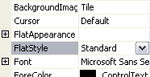
Congratulations. You just learned the Basic of Designing an application! ☺
Basic Coding: If this check box is checked, and I click this button, do this, if not, do this..
Okay. So we are going to be using a checkbox, a textbox, a label, and a button. So remember when I taught you how to add those? Add one of each.
Rename the Checkbox (just like I taught you to name objects, remember? Its text in the properties.)
Ill rename it to: Yes
Now rename the button to: Submit answer.
Rename the label to: Do you like pizza?
And just put the textbox somewhere and Disable it (make it so you cant type in it, only the program can) to do this, click the textbox once to select it, and in properties(bottom left like I told you.) Find Enabled and set it to false.
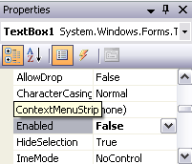
Now… Adding the code in
Right click on the form, and click view code.
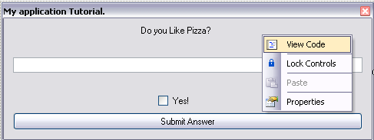
Now. We want to make it so when we click the button, if the Yes is checked, then the textbox’s text will say YAY.
And if you click the button when yes is not checked, then it says, aww.
Ok so.
At the top of the code input area is 2 Comboboxes
Change the first one to Button1, change the second one to click. It will now add in the code. This code is put in a sub, like a sub section. To determine the ending of a sub, you simply type end sub.
Anyways, after you put Button1, and click in the combo boxes, you got this..
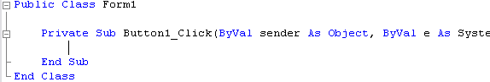
Public class meaning the entire form’s code.
Private sub meaning its functions are not shared with other forms you may add(to add forms you click Project->add windows form)
And the end sub and end class tells it when that section ends.
So we want it like this:
If button1 is clicked , then we want textbox1’s text to say “YAY”.
If its not, then textbox1’s text will be “aww”.
So our code will look like this:
If checkbox1.checked = true then
Textbox1.text = “yay”
Else
Textbox1.text = “aww”
End if
Notice that checkbox1.checked, there is more than just checked, there is so many more options, when you type Checkbox1 or textbox1, then you put the “.” A whole list will appear for you to choose from.
But so far our code looks like this.
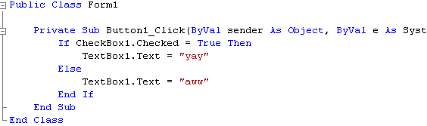
Good. Now if you want to test that, at the top, click Debug->Start Debugging.
Here’s another thing you can do for practice….Add a Textbox and 2 Buttons. Rename the buttons to Enable and Disable.
So you will be making a small application, when you click the “enable” button, the textbox enables, when you click the “disable” button, the textbox is disabled.
But wait. There are 2 Buttons. Meaning Button1 and Button2, and you don’t know which one is which! To find out which one, click on the designer, click the button and in properties look for this:
Now you know that the button you clicked is button1. So say button1 is the “enable” button and button2 is the “Disable” button. Go to the code. In the 2 Combo boxes, these:
Make it Button1 and click and in the sub just added, type in Textbox1.enabled = true.
Now in the top combo boxes, make it Button2 and click.
And in the sub that was just added, type in Textbox1.enabled = false
Now you can debug your app(test it)
Heres my outcome(in this picture I just clicked disable):
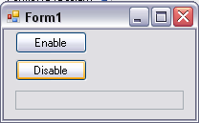
And my code looks like this:
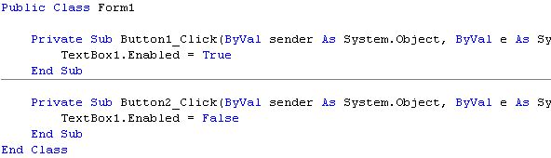
Nice. You just coded an application. Congratulations.
Saving the project and getting the .exe
Click File->Save all
You’ll get this…
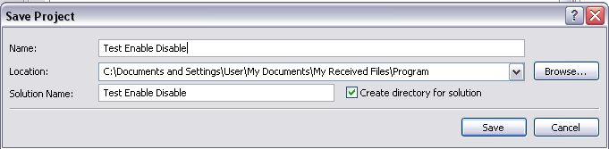
Now, go to the directory you saved it in. (See? Location there? The second Textbox?)
See the Name there we put in? And the solution name?
The directory will be The location + solution name + solution name + bin + debug
So mine will look like:
C:\Documents and Settings\User\My Documents\My Received Files\Program\Test Enable Disable\Test Enable Disable\bin\Debug
the .exe will be there from the last debug you ran.
Or
You can get it from the same place only instead of Debug, the directory will be release so in my case..
C:\Documents and Settings\User\My Documents\My Received Files\Program\Test Enable Disable\Test Enable Disable\bin\Release
Only It wont be there unless in your VB.net you click Build and you Build the project.
Cool you just got the .exe
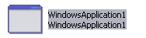
But see how its called Windows Application1? And you’re a guy who wants to change that right? So in VB.net, on the right double click this…
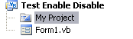
See? Click My project.
Now click Assembly Information
And this will pop up..
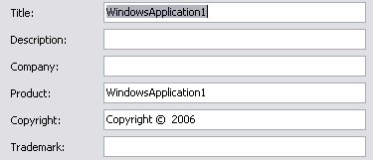
Change all the WindowsApplication1’s to whatever you want it to say. Or if you don’t want it to say anything below the title, just put a space.
Making A Halo 2 Map Resigner
Add 2 Buttons, Open Map, and Resign Map, and a textbox(to tell the path where to resign the map.)
Ok. Rename the buttons to Open Map and Resign Map.
Make Textbox1 disabled for reducing user error, and make resign map disabled(cause you cant resign a map that isn’t open)
Add the sub for the Open Map.
And insert the following code..
Dim DeToX As New OpenFileDialog
DeToX.Filter = "H2 Maps|*.map"
If DeToX.ShowDialog = Windows.Forms.DialogResult.OK Then
TextBox1.Text = DeToX.FileName
Button2.Enabled = True
End If
Dim DeToX as New OpenFileDialog.
Notice that line. That line is declaring that DeToX is a new OpenFileDialog.
The Detox filter, filters the files your looking for.
H2 Maps would appear here in the open file dialog:
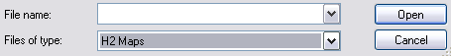
and *.map is the filter, it filters for .map
If DeToX.ShowDialog = Windows.Forms.DialogResult.OK
is saying that if the dialog is shown, and a result of it is a file selected, then…
TextBox1.Text = DeToX.FileName
Button2.Enabled = True
This is saying that The text in Textbox1 is the directory of the file.
And then it’s saying button2 is enabled (because the map is now open).
And of course you need to tell it to end if or else you get an error.
Now make a sub for the resign map button.
and insert this code…
Dim DeToX As New System.IO.BinaryReader(New System.IO.FileStream(TextBox1.Text, IO.FileMode.Open, IO.FileAccess.Read, IO.FileShare.ReadWrite))
Dim BW As New System.IO.BinaryWriter(New System.IO.FileStream(TextBox1.Text, IO.FileMode.Open, IO.FileAccess.Write, IO.FileShare.ReadWrite))
Dim shizzle As Int32 = 0
DeToX.BaseStream.Seek(2048, IO.SeekOrigin.Begin)
For i As Int32 = 2048 To DeToX.BaseStream.Length - 4 Step 4
shizzle = shizzle Xor DeToX.ReadInt32()
Next
BW.BaseStream.Seek(720, IO.SeekOrigin.Begin)
BW.Write(shizzle)
DeToX.BaseStream.Close()
BW.BaseStream.Close()
DeToX.Close()
BW.Close()

MsgBox("Done! The Signature Now Is: " + Hex(shizzle))
-DeToX is being declared as a Binary Reader(Binary readers read files)
Its telling it to read the file path in Textbox1, open the file and read it, that’s what its saying in the bracket.
-BW is the same thing only a Binary Writer(writes values, integers, in this case it will be writing shizzle, which is an Int32.
-Shizzle is declared as an Int32 and its value is 0,
-The binaryreader is seeking 2048..
i is an interger equal to 2048,
-shizzle is Xored by the read int32,
-then the Binary Writer seeks 720, writes shizzle.
-The Binary Writer is closed.
-Same with the Binary Reader.
That’s it! You just made a Map Resigner!
Using Picture Boxes to Hold your Image
This is the easiest thing ever. Make a picture box. Select it, in properties find Background Image
Click the little button on the right.. and this will pop up…
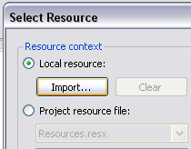
Click Local Recource and click Import. Find the image.
Then click “OK”
then in properties find backround image…
You can change the way the picture is set up. You can make it tile around the picture box, stretch around it. Your choice. Also… Your done that section!
Making a Simple WebBrowser
Add… A webbrowser. A button for stop, a button for Go, a Button for Back, a button for forward,a button for refresh, and a textbox.
For the Back button put the following code in..
webbrowser1.GoBack()
For the forward button:
webbrowser1.GoForward()
For the Go Button:
Webbrowser1.Navigate(Textbox1.text)
For the refresh button:
Webbrowser1.Refresh()
For the Stop Button:
Webbrowser1.Stop()
NOW: If you want to make it so when you click enter, It will go, with the two comboboxes that make the subs, set the them to Textbox1 and keypress and put the following code in the sub:
If (e.KeyChar = ChrW(13)) Then
Me.webbrowser.Navigate(Me.TextBox1.Text)
End If
Tutorial Made by –DeToX-
Enjoy!

