Prologue
For all of you non programmers out there I read the Visual Basics tutorial and didn’t understand a thing he said, but after reading and re-reading I finally got the hang of some things.

What this Tutorial is About
This tutorial is to show you how to add another input box into your program and link it with the map.

Step 1:
If you haven’t already, go read this tutorial on how to open and edit a map with Visual Basics-
http://files.halomods.com/viewtopic.php?t=50491

Step 2:
Open up your “Editing Halo 2 maps.vb” project file.

Step3:
Goto Form1.vb [Design]

Step3:
Now create a new TextBox.

Step4:
Now open your Form1.vb and Scroll down until you find this code:
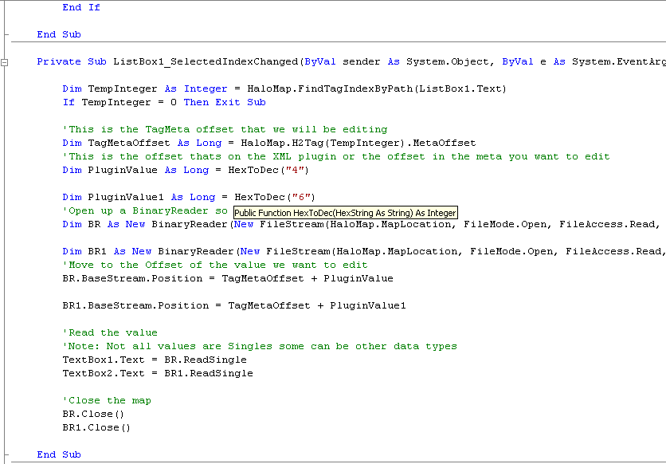

Step5:
Now this is were it gets kind of tricky, what we want to do is create a new BinaryReader. So basically what u do is copy this line-

- and paste it about a line down; Like SO. Now rename the Dim BR to Dim BR1, this is so that the binary reader isn’t loading two binaries into one.

Step6:
Now scroll up a little bit until u reach this code-

Now copy this code and paste It about a line down and rename it to something like this-

This is the plugin value of your new textbox. Six isn’t an actual offset I just made it up on short notice.

Step7:
Now Scroll down until you find this code-
Now Copy this code and paste it about a line down then rename it to something like this-

This just ummmmmm… clarifies everything.

Step8:
Now comes to the fun part-
Scroll down till you find this code-

Now copy this code and paste it about a line down then rename it to something like this-

Alright basically what this line of code does is it takes the binary data from our newly created Binary reader and puts it into our new created TextBox.

Step9:
Last but not least u cant forget this line of tag-
Scroll down until u find it-
Now copy this code and paste it about a line down and rename it to something like this-
Now That’s It Just go to and build the VB file.

What my program looks like-
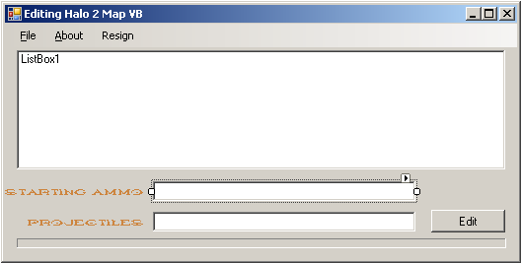

Extra Help:
All of the code in this tutorial is held within the listbox1 sub.

Anubus12
GamerTag – Henly88

Mad Props go to xxAntmanxx!!!!

