Hello members of the community,
i bring to you this little tutorial (with mod & meta) i made for easy weapon modding so people that join your game on XBC can see all projectile swaps. Many people might say that there are too many tutorials about it, but this one has got something extra that helps you along modding the weapons and it will probably save you a lot of time. I wanted to make it easier for people.
Also i have included a homebrew map with these kind of weapon mods and with spawn / teleport modifications for example.
It's a SPPF patch Click to download the SPPF - patcher
I started modding like this since I wanted to show the non-modding world what mods CAN be about (fun fun fun)(in stead of cheap spawn mods / cheating mods). I didn't like other people's reaction over halo2modding most known modding=cheating.
Download my Ascension mod (and host) to see what it will be like. It's got some swapped visible projectiles on each weapon
(for example overshield / warthog tires (all bloc tags but they are projectiles that do damage (meta faking)) and people are able to see those coming out of a gun as well).
This is what i did for your interest
I extracted the meta for each weapon that has been duplicated. Where you normally need to remodel the duplicated rocket launcher to make it look like the normal weapon again and make it have ALL properties, there u simply need to inject the meta (no more b0ring 10 min of swapping for 1 weapon). Since it costed me alot of time remodeling the weapons and make it look/behave like the original weapon again, this you will find quite valuable WHEN interested in XBC/fun-modding.
CLICK HERE TO DOWNLOAD META YOU WILL NEED
HOW TO MAKE VISIBLE PROJECTILES
*easyfied
1 ) open up a map in Insolence
2 ) Go to WEAP tag > rocket launcher... Duplicate it 8 times (using RightMouseButton): (you need it for each weapon you want modded: 1 magnum, 2 needler, 3 battle rifle, 4 carbine, 5 shotgun, 6 smg, 7 sniper rifle, 8 brute shot)
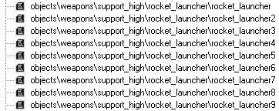
*note: you duplicate rocket launcher for weapons with reload
3 ) Go to Plasma Pistol... Duplicate it 4 times (you need it for each weapon to be modded: 1 brute plasma, 2 plasma rifle, 3 sentinel gun, 4 beam rifle)
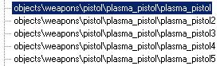
*note: you duplicate the plasma pistol for weapons with battery
Now you have got enough rocketlaunchers and plasma pistol's duplicated for each weapon in the map.
***CLOSE INSOLENCE***
4 ) Open the map up Dothalo
*NOTE: repeat these steps for each weapon you want to make visible*:
5 ) Go to WEAP tag
6 ) Go to newly duplicated rocket launcher > rocketlauncher 2
7 ) COPY meta offset from Rocketlauncher 2
**meta offset wtf??**look below
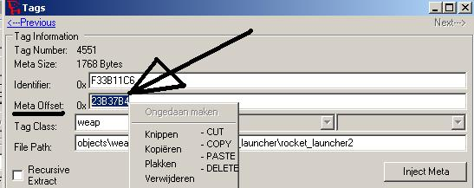
8 ) Go into WEAP tag and click the first weapon you are going to mod
> (for example) MAGNUM and PASTE the meta offset in the magnum (replace magnum meta offset with the rocket_launcher_2 meta offset).
*hit
9 ) Now click the weapon Rocket Launcher 2 again > now . Use the meta offset from the magnum (magnum.weap.meta) (!!!) i included in download.
[simply said: it is replacing all weapons' meta offset with new meta offset from the newly duplicated rocket launchers/plasma pistols then inject weapon meta into new rocketlaunchers & plasma pistol for saving time(normally you need dependency swapping)]
**YAY your first weapon is modded***

now you swap the projectile to desire... AND it saved you alot of time since, you do not need to swap each dependency.
_____________________________________________________________
Do this for each weapon you want to make visible just stay close to the steps. Do not use thesame rocket launcher/plasma pistol meta offset for other weapons, you have just duplicated a right amount of rocket launchers and plasma pistol's for each weapon in the map
_____________________________________________________________
**NOTE: on certain maps you cannot make weapons with battery visible for some reason (since all it does is mess up your weapon)
*do not ask me why but it does.
Here are the maps listed so do not attempt making them battery weapons visible on the following maps (duplicate rocket launcher only) :
- Colossus
- Zanzibar
- Backwash
- Deltatap
- Elongation
- Turf
- Warlock
*note: for each weapon i have included meta that you can inject over a duplicating pp/rocketlauncher once you have done the "meta fake".
I was getting lazy with the Beam Rifle, so now you can charge up your Beam Rifle and it has got a 2nd projectile as well :shocked:
*note: there is also meta for the warthog_horn.weap .. you can just inject this into the warthog_horn (found in weap tag) and it's visible
_____________________________________________________________
*****Little extra on making weapons visible:*****
You can also make your ghostgun / bansheegun / flying turretgun appear on other people's screen just follow the next steps:
1 ) First open up map with h2x
2 ) Goto banshee_gun > click META EDITOR and memorize all info (or find another way since you will need that info in step 6)
____________________________________________________________________
3 ) (again) Duplicate a plasma pistol for the bansheegun
4 ) Copy the newly created plasma pistol meta offset into the banshee gun *hit save changes
5 ) Null out all dependency and make it look like this:
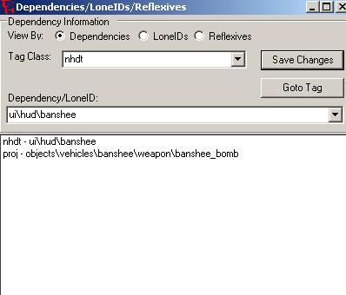
you can set projectile yourself
____________________________________________________________________
now the tricky part
6 ) Open up the map with h2x and go to banshee gun again (click META EDITOR) and edit it (with info from step 2) so the banshee_gun isn't a banshee_gun with plasma pistol properties anymore
DONE!!!
*Note The turret gun must be a flying one!!
>>QUICK HOW 2 MAKE flying spectre/plasma_turret (or scorpion/ghost) in a good way without messing up your original banshee
1) Duplicate a banshee, and copy newly created banshee2 meta offset into spectre/plasma_turret
2) Change hlmt tag back from banshee to plasma turret)

