Modeling Using Only Entity
By: -DeToX-
Extracting Models
Open Entity. Go to the mode tag. Click the tag of your choice to extract. Then at the top right click the little “+” sign. And click export meshes->to .OBJ.
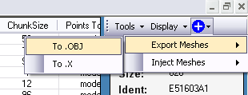
Then find the folder you want to save it to. That’s it you extracted it.
Injecting Models and Making weapons use them
Open your map. Go to the mode tag. Now say the model was extracted from the FP(first person) SMG. And edited. You will click the FP Smg Tag. Then in the top right click the “+” sign and click Inject Meshes-> Inject .OBJ
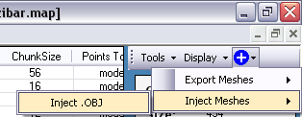
Then find the folder containing the model. Click “ok.”
Then something will pop up(you will enter the a new name)
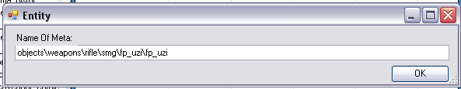
See? Just like I did. And you click OK and it will create the new Mode tag for you.
Then it will say Done. There you go! Injected.
Making the weapons use the models
Now. Open Entity. Open your map.
Listen... if your model injected is not a First person model go to the hlmt tag and find the weapon to use the tag. So I click the SMG hlmt. Then right click on the chart and click Display-> Idents.
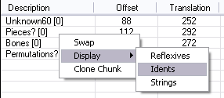
Then you will see your model here. Right click on it and click swap. Swap it to your new model.
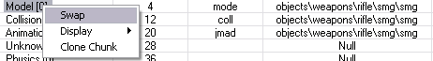
For an First Person Model
For a first person model… Go to the weap tag and click on the weapon you want to use the first person model. Right click and click Idents like shown here:
Scroll down to find your model. Swap it by right clicking on it and clicking swap. Then swap it to your new model.
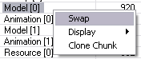
Now, there are 2 models (as seen above, Model [0] and Model [1]), one for the Elite, and one for the Masterchief so swap both to your new one.
That’s it! Congratulations. Sign Map and FTP to get your weapon!
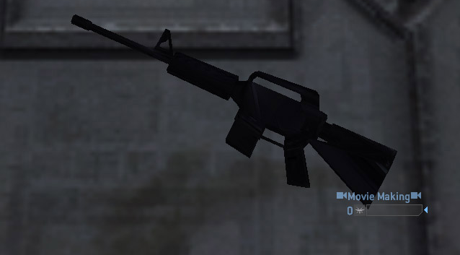
Tutorial Made by: -DeToX-

