Making An Xbox ISO and Changing the XBE Title
By: -DeToX-
Well as many of you may know, normal ISO’s wont work on Xbox’s. So I will teach those who don’t know how to make an Xbox ISO which may be needed for burning games to a Disc or Map Packs such as the KillTrocity Map pack. It will also tell you how to edit the XBE title (the name of the game when you put it in the DVD drive).
Things Needed:
-C-Xbox-Tool ( http://www.cxboxtool.xbox-hq.com/downloads/c-xboxtool206.zip )
-A folder of everything in it (The XBE(s) and any folders originally in the game.
Editing The XBE Title
Open The C-Xbox tool and on the left click “Edit XBE Title.”
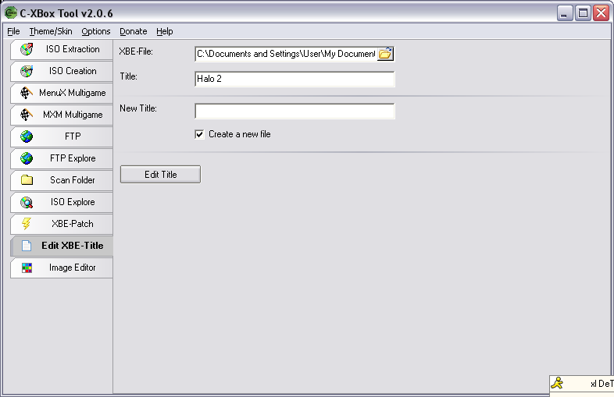
Then click the little folder shown after the XBE-File to browse for it. Find the XBE…
Click on it to open it. Then leave title alone. In New Title type in your title. Mine will be “Killtrocity Map Pack.”
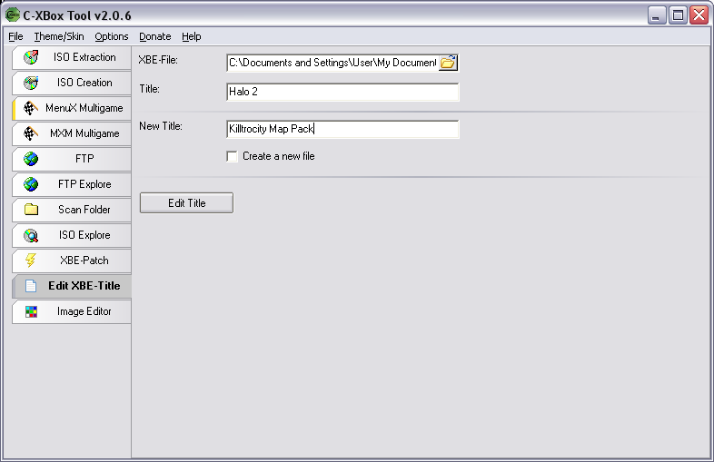
Uncheck the Create a new file. And click edit title. That’s it!
ISO creation
Open C-Xbox and click ISO Creation. Click Add Folder, The source folder will be where the folder where the game is in (no other files should be in the folder but the game). Target folder will be where you are saving your Xbox ISO file. For the filename you will put in what you want the file to be called. Make sure the file name ends with “.iso”.
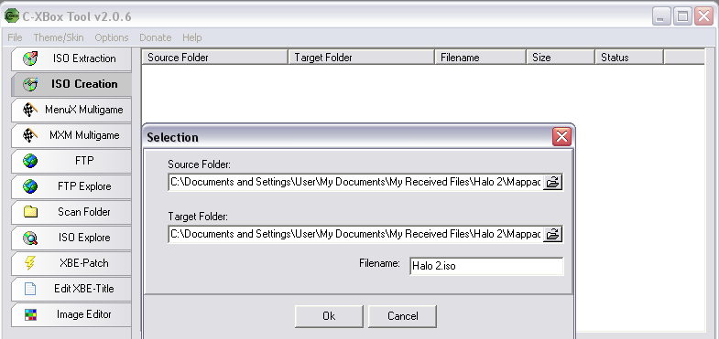
Then click “OK”. At this point you can create more ISO files. Just Add Folder again, add another one. Once your ready to make all of your ISO’s Click “Start” and wait until it is complete. Congratulations. Now you just burn the Xbox ISO to a disc and you’re done. Nice job.
Tutorial Made By: DeToX

