CHAPTER 1
====Section 1====
==Setting Up a Modding Environment==

I. WinRAR

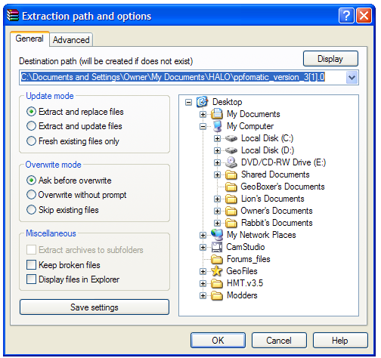

When you download modding programs, it is often that the program will be compressed--simply meaning that it will be reduced to a smaller size so that you can download it faster. There are two very common compression types: .ZIP and .RAR. To extract the data from these files you will need WinRAR.

1. Download WinRAR (extracts the contents of compressed files):

Link 1: http://www.download.com/WinRAR/3000-2250_4-10446177.html?tag=lst-0-1
Link 2: http://www.rarlab.com/rar/wrar351.exe
Link 3: http://www.win-rar.com/index.php?id=160&dl=wrar351.exe

Once you have downloaded it, install it.

II. Halo Map Tools

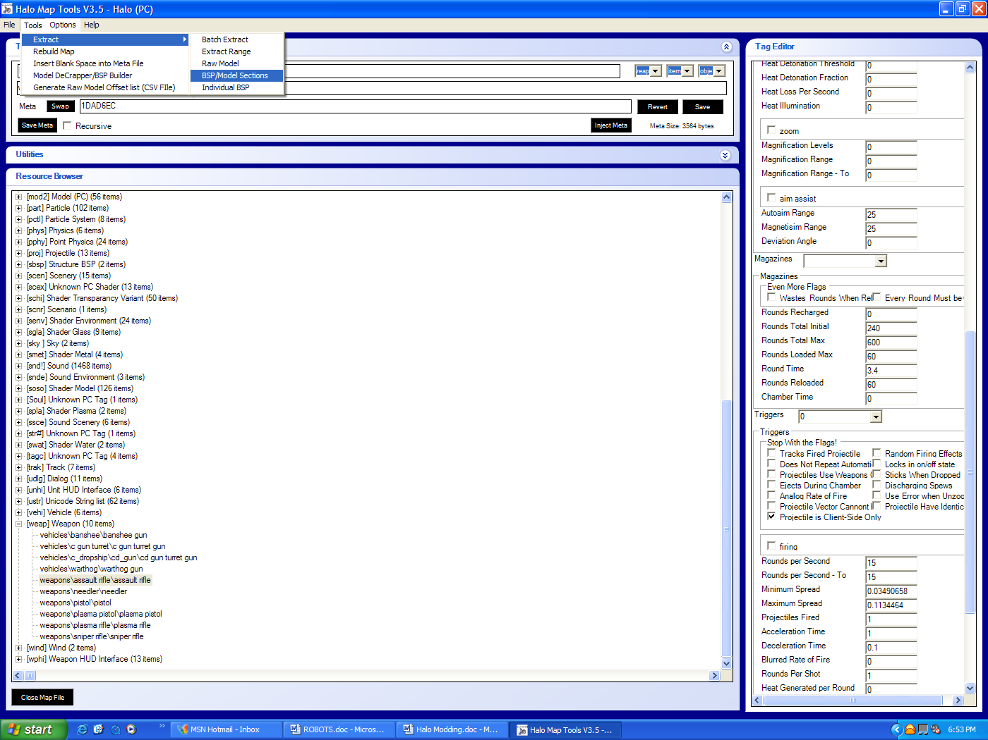
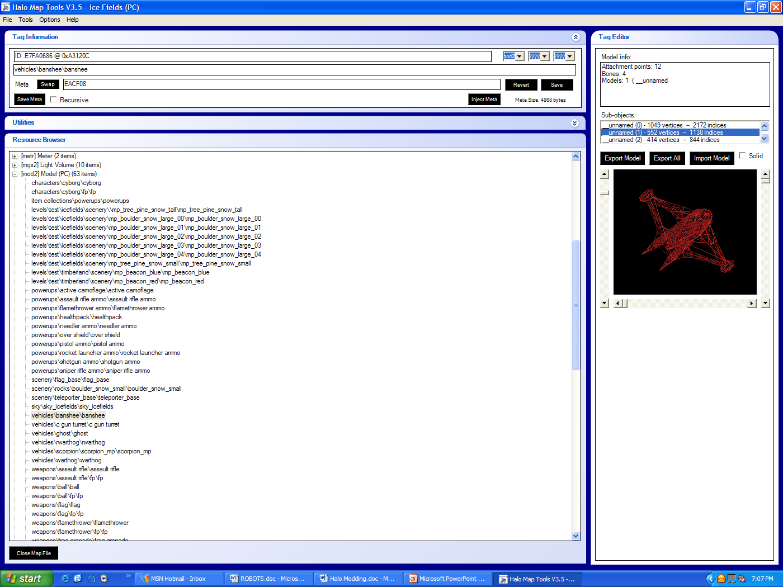
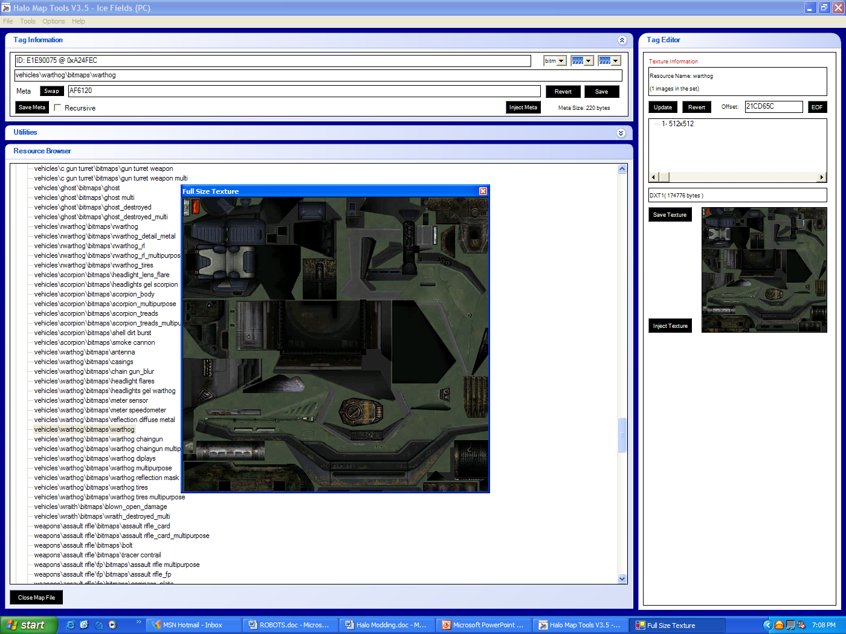

Next you’ll need the most basic yet complicated modding tool: HMT. Created by MonoxideC, this program can mod the hell out of Halo.

2. Download HMT:

Link 1: http://files.filefront.com/HMT_v35rar/;4918103;;/fileinfo.html

------------------------------------------------------------------------------------------------------------

Link 1 is the highly suggested download site because it has extra plugins. If for any reason link 1 does not work, then please try:

Link 2: http://www.download.com/Halo-Combat-Evolved-mapping-tools-utility/3000-7453_4-10286367.html

OR

Link 3: http://files.halomods.com/download.php?id=8073

Extract the contents when the download is done. Test if it works by double-clicking the application: HaloMapTools.exe. If an error message pops up, that indicates that you do not have the .NET Framework yet. Do not worry, you can get it here:

http://www.microsoft.com/downloads/details.aspx?FamilyID=262d25e3-f589-4842-8157-034d1e7cf3a3&displaylang=en

The download time will depend on your connection speed. On a 56k modem (dial-up) it will take approximately 57 minutes. On a T1/LAN or Cable it will require only about 2 minutes.

Unfortunately, MonoxideC has announced that HMT v3.5 will be the very last version of HMT that he will release. Maybe one day another bright person will come out with a similar program.

If you chose Link 1 as your download link, skip this step. If you chose download link number 2 or 3, please download these extra plugins as you will need them later:

http://files.filefront.com/Pluginsrar/;4953619;;/fileinfo.html

The files are stored in RAR format so extract it with WinRAR. Copy the contents, navigate to where HMT v3.5 is located, open up the “plugins” folder, then paste the new plugins in there. Click “Yes to All” when a box pops up asking if you want to replace any files.

III. PPF Program

Now you will need a PPF applier. There are several you can choose from:

A. Kore’s Halo Tweaker. It applies PPF’s and can create PPF files too.

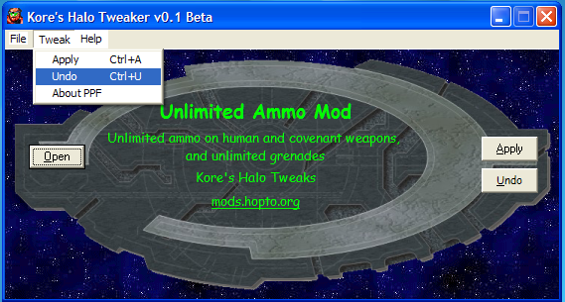

Link 1: http://www.forums.korerekon.com/download.php?id=52
Link 2: http://files.filefront.com/KHT_Sedtupmsi/;4917950;;/fileinfo.html

B. PPF-O-Matic. Applies ISO files to maps.

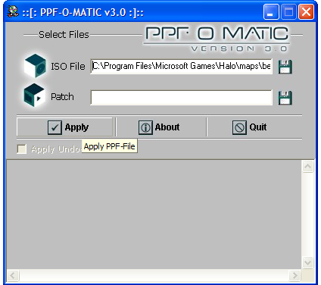

Link 1: http://files.halomods.com/download.php?id=5
Link 2: http://files.filefront.com/ppfomatic+version+30/;2539066;;/fileinfo.html

C. HHHT (Helpful Halo Hacking Tools), Applies PPF’s to maps.

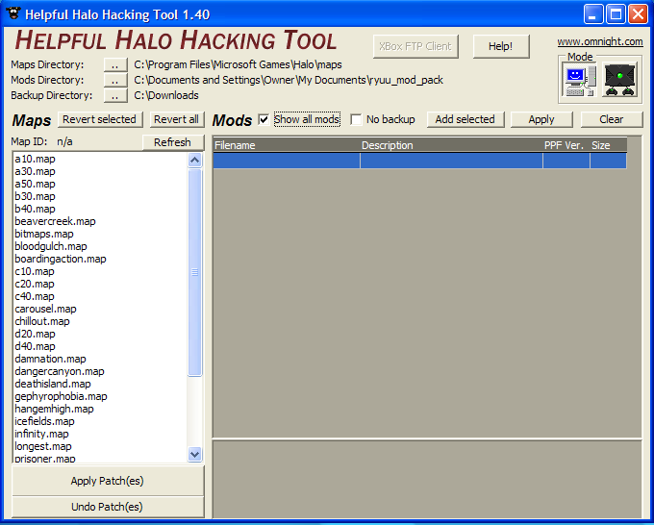

Link 1: http://halo.ogresnet.com/downloads/db/?act=download&id=19&agree=yes
Link 2: http://videogames.yahoo.com/download?eid=321275
Link 3: http://dw.com.com/redir?pid=10292159&merid=6262002&mfgid=6262002&ltype=dl_dlnow&lop=link&edId=3&siteId=4&oId=3040-7453_4-10292159&ontId=7453_4&destUrl=http://www.download.com%2F3001-7453_4-10292159.html (sorry for the long link)

IV. Halo Hacker Tools

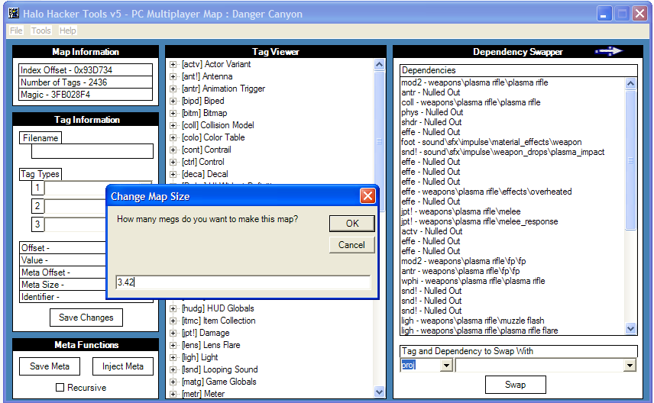

This is a program similar to HMT v3.5 even though it is slightly different in certain areas. Note that this cannot be used for the trial version of Halo. The following links are for the version 5 of HHT. Credits to CLuis.

Link 1: http://files.filefront.com/hht+v5/;3943793;;/fileinfo.html
Link 2: http://files.halomods.com/download.php?id=1731

V. Spark Edit

This is a must-have program for Halo modding! You can zoom through any map and duplicate objects, add teleporters, create skybases, sniper towers, and so much more. All thanks to Grenadiac!

Link 1: http://files.halomods.com/download.php?id=4439
Link 2: http://www.download.com/Halo-Combat-Evolved-SparkEdit-Mod/3000-7453_4-10265779.html?tag=lst-0-1

This program is also for the FULL version of Halo ONLY but there is a PPF that you can apply which will allow Halo Trial users to be able to use SparkEdit v3.0 and all other patches (v3.01 and v3.02). Below is the Halo Trial version of SparkEdit PPF:
http://files.halomods.com/download.php?id=48183

VI. Modeling Program

A. Lightray 3D

Although this program may not look like it’s worth downloading but it’s the full version and is not for trial. I would say it’s worth having but if you insist on buying something, try choice B. MilkShape 3D.

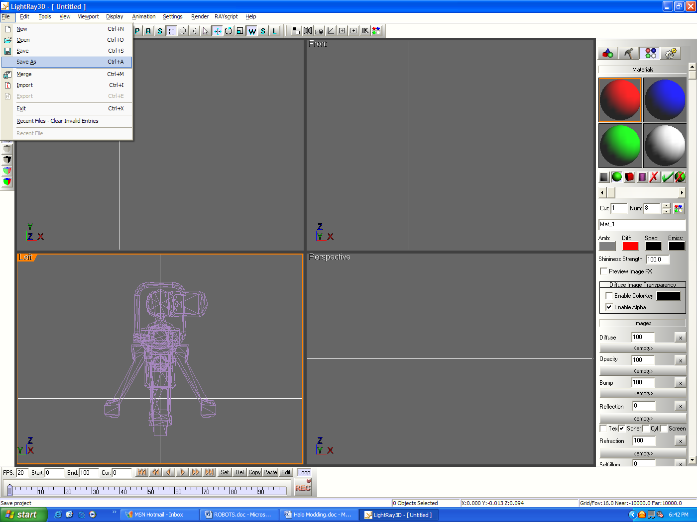

http://www.sxcreations.com/Download/Files/LR3D_136.exe

B. Milkshape 3D

Originally this program was created for Half-Life but it has the power to modify models from just about most games. The disadvantage of this program is that it is not free and you must buy it unless you want to try the trial version of it which expires in 30 days.
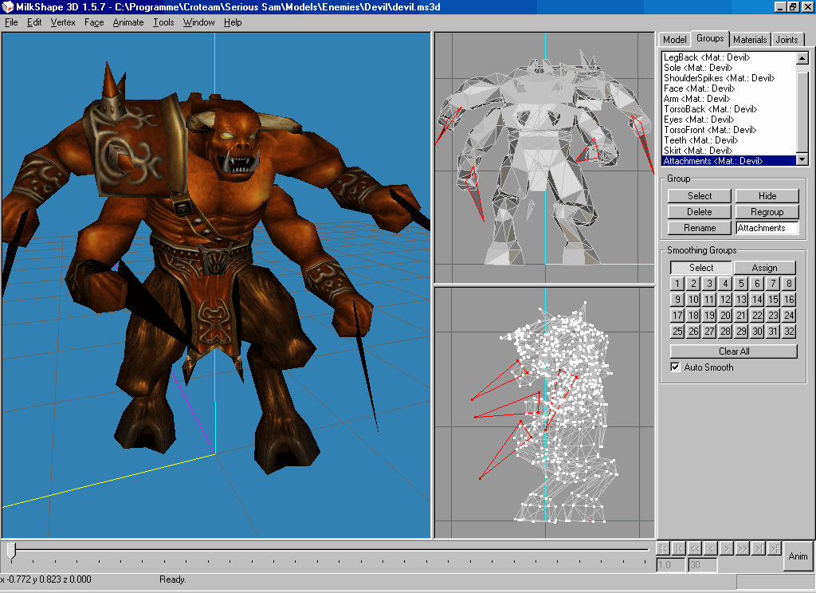

http://www.swissquake.ch/chumbalum-soft/ms3d/download.html

There are more modeling programs but since these are the only ones we will be using in the tutorial, then I will only introduce these. However, if you know any other programs then you are welcome to skip the modeling tutorial section and use your own help files from other sources.
VII. DTXBmp

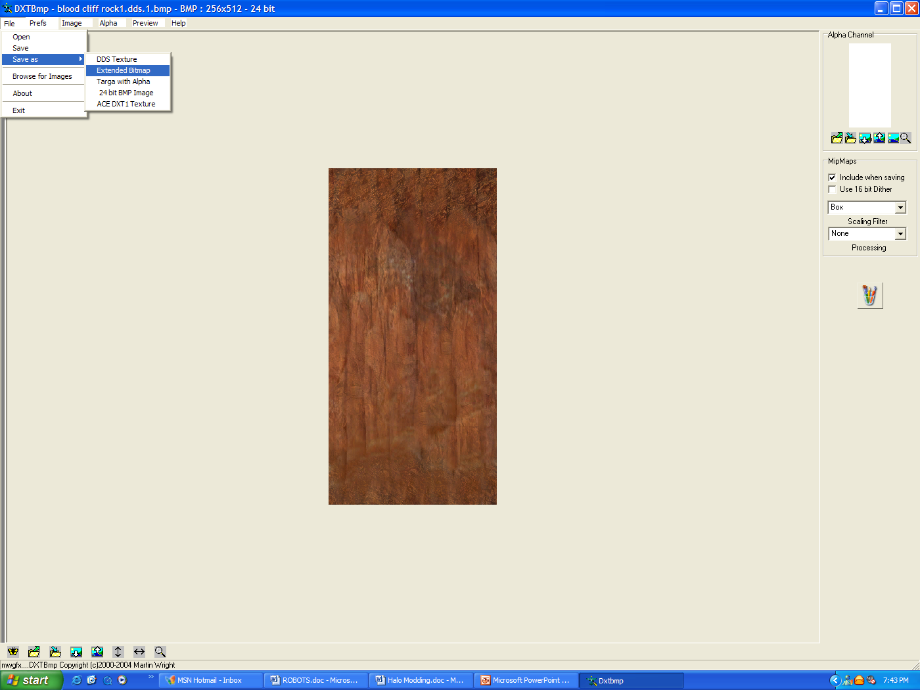

This program is used to convert DDS textures into .bmp files and vice versa. This is very important as you will need it to skin Halo.

http://perso.wanadoo.fr/melgesclub//DXTbmpTools.zip

