Grunt Mod/ Difficulty Mode Selection

Key: # =Org.
#= Modded

-----------------------------------

Easy/ Easy Peesy
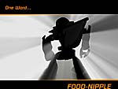
Easy Mode: Your foes cower and fall before your unstoppable (Grunty) onslaught, yet final victory will leave you wanting more. (foodnipple)

Your Brilliance in the field is only surpassed by your absolute gruntyness. This is like a walk to foodnipple

Normal/ Grunty Greatness
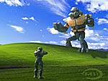

Normal Mode: Hordes of aliens (and tin men) vie to destroy you, but nerves of steel and a quick trigger finger give you a solid chance to prevail.

This mode is a wee bit harder, but as long the stupid jackals don’t get in the way, winning is almost guaranteed

Heroic/ Oh My
 or 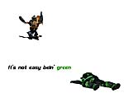

Heroic Mode: Your enemies are numerous as they are ferocious; their attacks are devastating. Survival is not guaranteed.

You have to work together and be your own team, Outsmart and outplay, Or death will be part of your grunty teams way

Legendary / Run Away


Legendary Mode: You face opponents who have never known defeat, who laugh in alien tongues at your efforts to survive.This is suicide
(so just jump off a cliff, save them the trouble)

IIEEEE…Run Away!!!
This Mode will Probably Kill ( us /You) all





