First Level AI in MP (Halo 2)
By: -DeToX-
Things Needed:
Entity Beta 1.2.1 (found at haloplugins.com , no www. )
Yelo 1.5 (Xbox7887’s New trainer)
In this tutorial I will teach you step by step on how to make flood infections chase you in MP. I will do this a different way without spawning in the AI placement palette in the scnr. Flood Infections run off a simple script that states, “Run to the chief, and when in the same Co-ordinates as him, explode.” So we will use Flood Infections because Proper AI has not been done correctly as of yet. But the creature of the flood infection could not be spawned alone. So we will make them spawn via killing the flood carrier.
Transferring what is needed to your map.
Open Entity 1.2.1; Open your maps, one single player map. And one Multiplayer map. I will use Sentinel_Walls and Midship.
Have the following Checked.
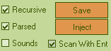
Then go to Char and click Flood Carrier and click save (the button shown above.)
And save the meta to a directory of your choice. Once finished…
DO NOT CLOSE SENTINEL WALLS.MAP, it will be needed still for later.
Open Midship if it isn’t Opened already.
At the bottom right click build.
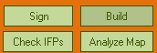
Then find the .info saved at the place that you saved your Meta of the char.
Click it. It will then build into your map.
Done Part one!
Part two: Relinking AI in the scnr so it works.
If Sentinel walls is not opened, open it and go to the scnr. Click on the scnr. In the grid right click and click clone chunk.
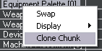
Then this will pop up.
Find Charecters.
Click it. Then click Copy to ClipBoard
In Midship go to the scnr, click the scnr, then right click in the grid, and click clone chunk. The Dialog will pop up. Click the second node.
And click Add to selected reflex/chunk.
Then click Add Meta to Map.

It will say done.
Spawning the AI.
We will now spawn the flood carrier, and when it blows up, little flood infections will follow you and try to attack you.
Let’s get going.
You can spawn it following MrBalll’s tutorial for “Adding New things.” But we will take the easy way and just make it spawn where the shotgun is. So in Entity go to itmc, click shotgun. Right click the grid and click Display -> Idents.
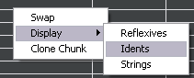
Then click the one Item that should be there. Then right click it and click swap.
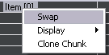
Then Change the first combo-box to “Bipd.” And change the second one to, “objects\characters\floodcarrier\floodcarrier.” And click Swap ident.
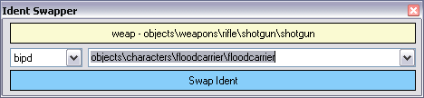
Click Tools, Fix System Link.
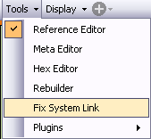
It Will say:

Click “Sign.”
And it will say “Done.”
FTP The map, Launch Yelo, Enable AI in MP. Play in Split screen(Not System Link.), kill the flood carrier and flood infections will come and chase you.
Worked For me…
But From what I noticed, some maps wont hold the AI you want. Like Headlong wouldn’t take the flood AI when I tried it, Midship did, Ivory Tower did. Maybe I just did something wrong there lol.
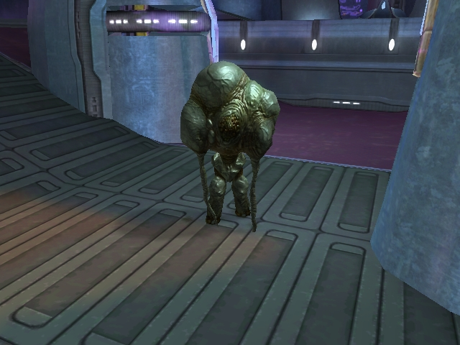
I just kill him and Little flood Infections spawn. Good Luck.

