Fixing System Link Compatibility with Entity
by: Trigger_six
Things you will need:
-Entity
-A Halo 2 Map
Opening your Map
To Get started, Open Entity. At the top is “file.” Click that and click Open. Find your halo 2 map.
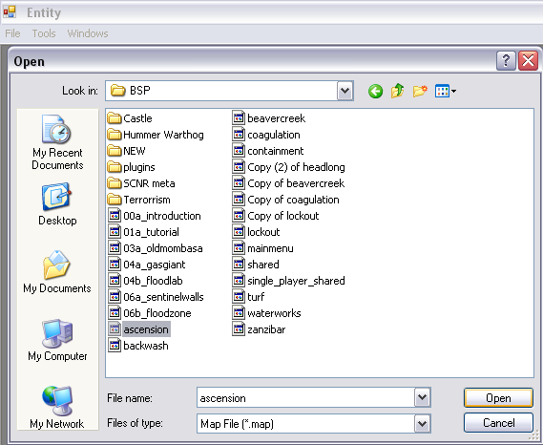
Cloning a predicted recourse
Now we will have to clone a predicted recourse in the Scnr tag. So go to the scnr tag. And click on the only tag that should be there. Then you will see many different things on the side. But the one you should click is Predicted Recourses. After it is Highlighted, right click the highlighted text and click “Clone Chunk”
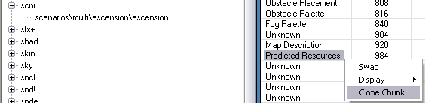
Then you will see a dialog come up asking how many chunks to clone. Type in the amount of chunks you want to clone(you should add as many chunks as you have tags that break SLC, the tags that break SLC are stated Below.). Then click “Add Chunks To Tag” and a message box will pop up saying “Done.”
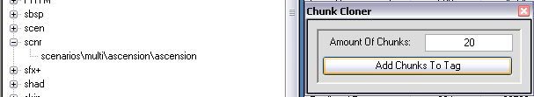
Referencing The Tags that break System Link Compatibility
These are the tags that break System Link Compatibility:
biped
bloc
ctrl
eqip
garb
jpt!
Mach
proj
scen
ssce
vehi
weap
Now, Right click in the area where all the reflexives are and click Display -> Idents.
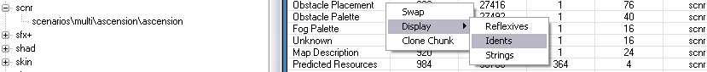
Now Scroll down and you will see the text “Recourse.” Go to the last ones (because the last ones are the ones you added.) Now Right-Click the text Recourse and click “Swap”
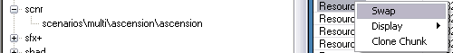
Now a dialog will come up. It will look something like this:
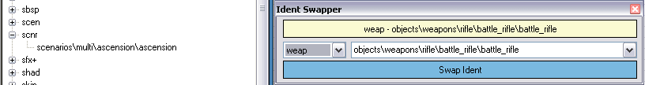
Now , in the beginning of this section I stated the Tags that break System Link Compatibility.
Make sure the you swap all the recourses so every tag is referenced that was added.
If reference every tag you added that breaks System Link Compatibility, you will fix the System Link Compatibility. For Example: You added a New Machine from one map to another, it must be referenced in the recourses and the map will be System Link Compatible again.
Again, the tags that break System Link Compatibility are:
-biped
-bloc
-ctrl
-eqip
-garb
-jpt!
-Mach
-proj
-scen
-ssce
-vehi
-weap
Credits:
I would like to thank Shade45 for being the first person to know how to fix System Link Compatibility and he taught everyone, so major credit to him.
Also I would like to thank Pokecancer for making Entity, the program used in this tutorial.

