Editing Effects in Dot halo
by: -DeToX-
Open your map in Dot halo. Go to the effe tag. Find the tag you’d like you’d change. Ill be using: effects\impact\explosion_large\scorpion_shell\shell_explosion
In dependencies, look and you will see prt3, PRTM and pmov tags.
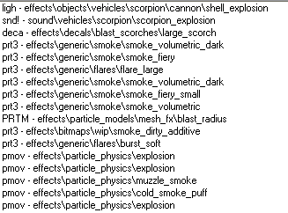
Swap these and you will come with different outcomes. You need to picture them. Like a plasma twirl perpendicular and plasma twirl(using the tank shell effect). Would look something like this:
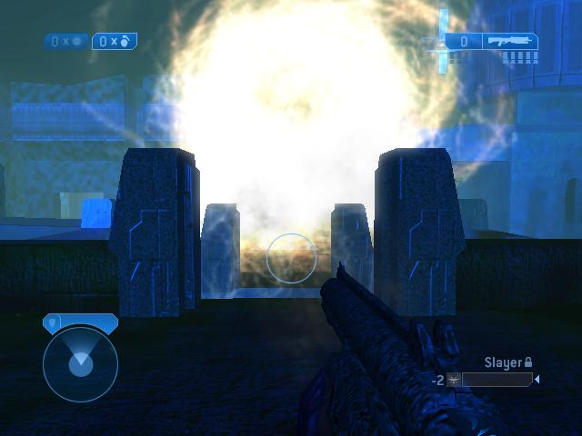
Only it comes out and its not all scrunched up, that’s just the beginning of the effect. (this picture was taken from Pacifica). Good luck. Try using different things. For a flamethrower.. I would use a gauss explosion effe and change all the prt3’s to fire. Then when the gauss exploded you’d get something like this:
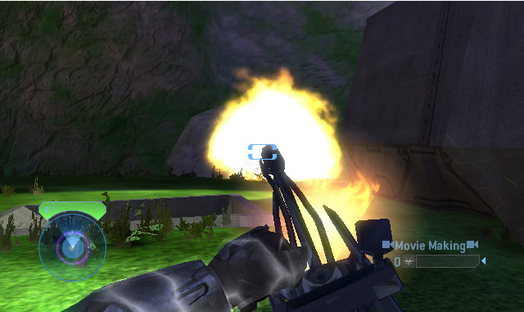
It’s a nice effect. Though for a gauss you may want to go to the jpt! tag and turn down the damage ☺. Have fun!
Tutorial by –DeToX-

