Citadel
By xheadshotmastax

In the tradition of Metroid Tunnel and Sentinel Base 2, xheadshotmastax has once again amazed the Halo 2 modding community with this work of art. Despite the limitations of Halo 2 modding, xheadshotmastax has created a completely new look, a completely new feel, and a completely new map altogether.

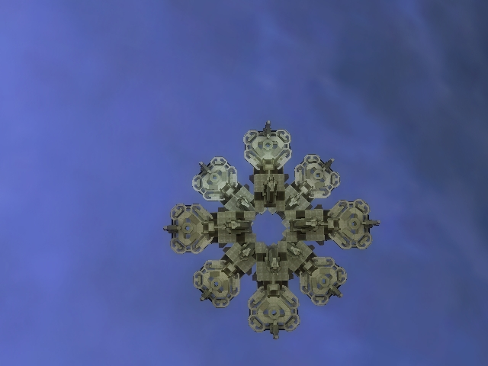
Upon hearing the omniscient voice announce the word “Slayer,” the player is introduced to a whole new world previously foreign to the game of Halo. In front of the Master Chief there are 4 platforms, aligned in circular pattern, floating high in the air. Above is an identical formation, though it’s offset from the structure below. In the middle is a gaping hole which passes through both the upper and lower layers. However, this hole indeed serves a purpose as it holds within its self the only link between the lower and upper layer: a “grav lift.”
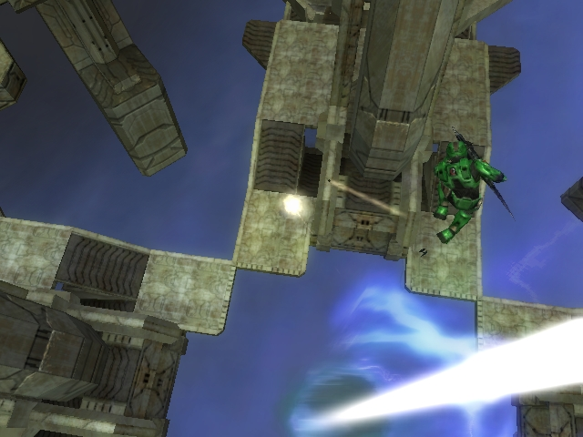

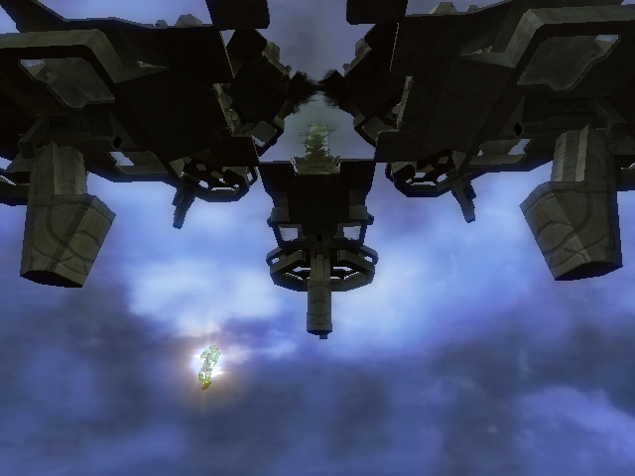
To reach the upper level, the player must take a “leap of faith” into the swirling blue column at the center of the level. Should he miss, he would fall into a carefully placed death barrier, courtesy xheadshotmastax. If he makes it, however, he is hurled upwards to the levels above. At this point he can choose which of the available platforms to land on and he can explore the same as he did below.

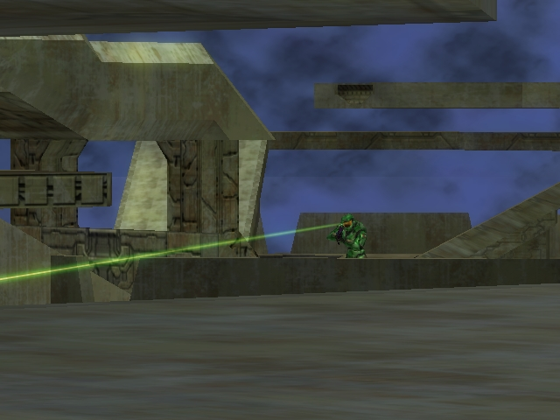
Without much exploration, the player should quickly realize that the weapons available are strictly Covalent-made and non-modded. This will prove to be a limitation to some, but a great advantage for others. However, each are on an equal playing field when it comes to finding these weapons. There are indeed enough weapons on the map to handle a large number of people, but there aren’t so much that one can just casually pick one up as he passes by. Those who are good at close combat are therefore at an advantage here.
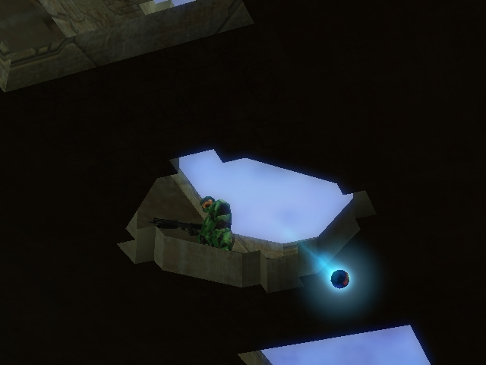
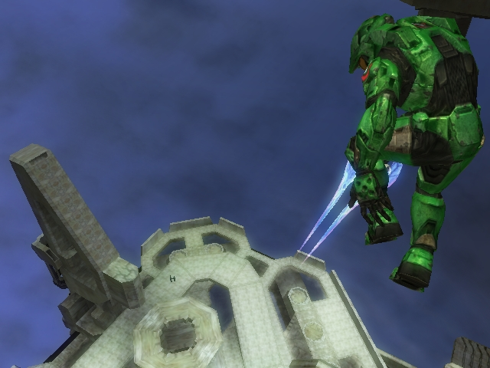
With the weapons in hand, players tend to find themselves on the upper level. At the top, one can see the entire playing field whether through holes in the structure or over the edge of the platform. Here, players take advantage of those less fortunate still fighting below, unable to reach the grav lift. They find themselves vulnerable to grenade attacks from above or even from surprise aerial attacks from someone wielding the hidden sword. In either case, the upper ground is the place to be.

In short, this mod brings a whole new playing experience the halo 2 fan. Fast-paced combat on a map this size has yet to be achieved on any other playing field. Whether playing with 2 or 16, this map never looses its excitement.

Reviewed by: theycallmechad

